

National Technical University of Athens

School of Civil Engineering

Acad. Year: 2020-2021

**Course: Stochastic Finite Element methods**

3rd Assignment

Consider the plane stress problem from the 2nd assignment:

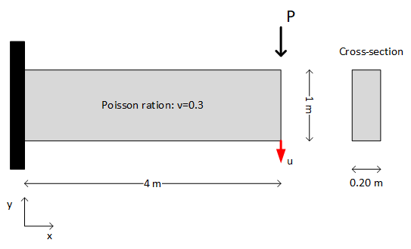

with $P\sim Ν(10,2)$ (kN) and $E$ given by the formula:

$$E\left(x\right)={10}^{5}\left(1+0.10f\left(x\right)\right) (kN/m^{2})$$

where $f\left(x\right)$ is a zero-mean stationary Gaussian field with unit variance. The autocorrelation function for $f$ is $R_{f}(τ)=exp⁡(-|τ|/3)$.

1. *Perform a set of 100 system evaluations for different realizations of $P, E$.*
2. *Use the POD/PCA method to construct a reduced system of equations for the problem, $K_{red}U_{red}=P_{red}$.*
3. *Perform Monte Carlo simulation on the reduced system and obtain the pdf of $u$ at the bottom right corner of the cantilever. Compare it with the pdf you obtained in the previous assignment for the full model.*
4. *Estimate the computational gain from POD.*